Year 5 & 6 Homework Grid- Our Heritage - Spring term
Try to complete one each week to earn yourself some dojo points! Don’t forget to practice your spellings, handwriting and reading at home too 🙂 If you have any questions please feel free to ask!
Maths-  Heritage Timelines  Create a timeline showing 5 key events from Welsh or Victorian heritage (e.g. opening of a coal mine, invention of a train).  Use equal intervals and label the years correctly. | Literacy-  Diary of a Child from the Past  Write a short diary entry imagining you are a child living in Victorian Wales or in a mining community.  Describe your day, your job (if any), and how you feel. | Theme -  Transport Through Time  Compare one type of transport from the past (e.g. steam train, horse and cart) with a modern equivalent.  Draw or write about how and why transport has changed. | Art- Heritage Collage  Create a collage using drawings or magazine pictures showing Welsh heritage or Victorian life.  Include at least 3 symbols or objects from the past. | Well-being -My Heritage, My Story  Talk to a family member about something important from your family’s past.  Write or draw one thing you found interesting or special.
Maths- Coal Cargo Calculations  Imagine a cart carrying 125kg of coal.  Answer questions such as:  How much coal would 3 carts carry?  If 500kg of coal is shared equally between 5 miners, how much does each get? | Literacy- Heritage Vocabulary Challenge  Choose 5 new words linked to our heritage topic (e.g. heritage, tradition, industry, transport, community).  Write a definition and use each word in a sentence. | Theme- 🌍  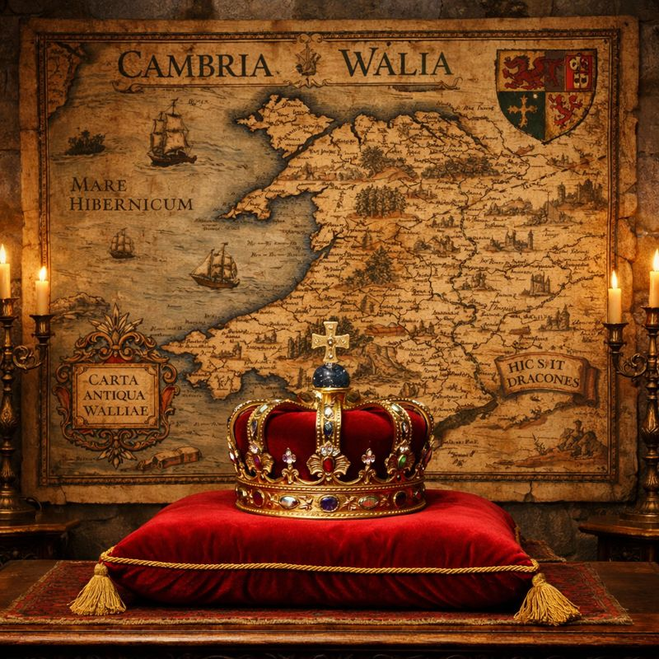  Welsh Symbols at Home  Find 3 Welsh symbols (e.g. dragon, leek, daffodil, harp).  Write one fact about each and explain why it is important to Wales. | Art- Design a Heritage Tile  Design a square tile inspired by Welsh patterns, coal mining, or Victorian designs.  Use repeating patterns and bold lines. | 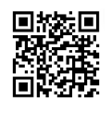  Well -being- Calm Then and Now  Choose a calm activity people might have done in the past (e.g. singing, storytelling).  Try it for 10 minutes and write about how it made you feel.  Scan the QR code to complete a mindfulness activity.

