

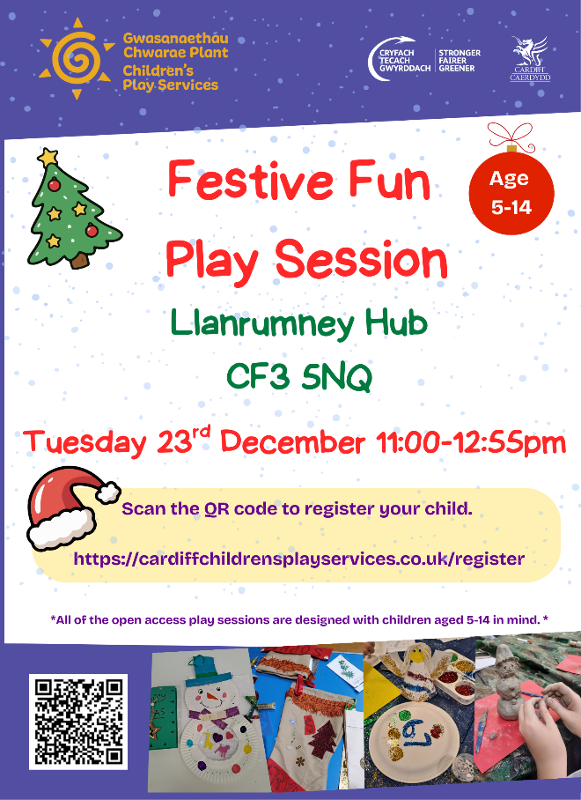







This year, one of the main targets for The Oaks Federation is focusing on improving our school attendance. This term attendance at Trowbridge has improved and is now 91% - thank you for helping us to achieve this and we hope that we can improve further in the Spring Term.
Thank you for all of your continued help to support the work of the school that ensures the best possible outcomes for your children.
On behalf of the Governing Body we wish you a Merry Christmas and Happy New Year.

Goodbye and Good Luck!

We send our very best wishes to Mr Wakeling, who will not be returning after Christmas. He has been such a valued part of our community and will be missed by staff and children alike.
Early in January, we will also be saying goodbye to Miss Vaughan. Another huge loss to our team, she has brought so much care and dedication, and we wish her every success for the future.
🌟 Exciting Changes Ahead
Miss Clayton will be moving from Year 1 to join the Year 3 team in January.
We are delighted to welcome Miss Colley to Year 6 and Miss Mills to Year 1.

Remaining INSET Days 2025-26

Monday 5th January
Monday 23rd March
Monday 8th June
Monday 20th July

Bank Holiday
Monday 4th May

‘School Motto’

The school Motto is:

‘Believe and you will achieve’

‘Credwch ac fe lwyddwch’

We try to apply this motto throughout our daily work at Newton Primary School.
Mo
School Meals

I would like to take this opportunity to remind you about paying for school meals.

Dinner money should be paid on a Monday in advance of having any school lunch. We would prefer for you to keep up to date with payments rather than having to implement the Bridgend CBC policy.

Thank you for your cooperation with this matter.

17.12.25 Nurs/Rec/Y3/Y4/5/6 Christmas Parties
17.12.25 Y2/Y3 Movie Night
18.12.25 Christmas Parties – Years 1/2
19.12.25 End of Term
5.1.26 INSET Day – no school for children
6.1.26 Children return to school

10 days absent = 95% attendance
19 days absent = 90% attendance
29 days absent = 85% attendance
38 days absent = 80% attendance
47 days absent = 75% attendance


💛 Welcome Families!
We’re delighted to share some wonderful news:

- Fairn Allen, our new Family Engagement Officer, will be here every Tuesday to offer support, guidance, and a friendly face for families.
- Mags Richmond is back with another Family Learning Course every Tuesday for Reception, Year 1, Year 2, and Year 3. This course is all about boosting reading skills and giving families practical ways to support learning at home.

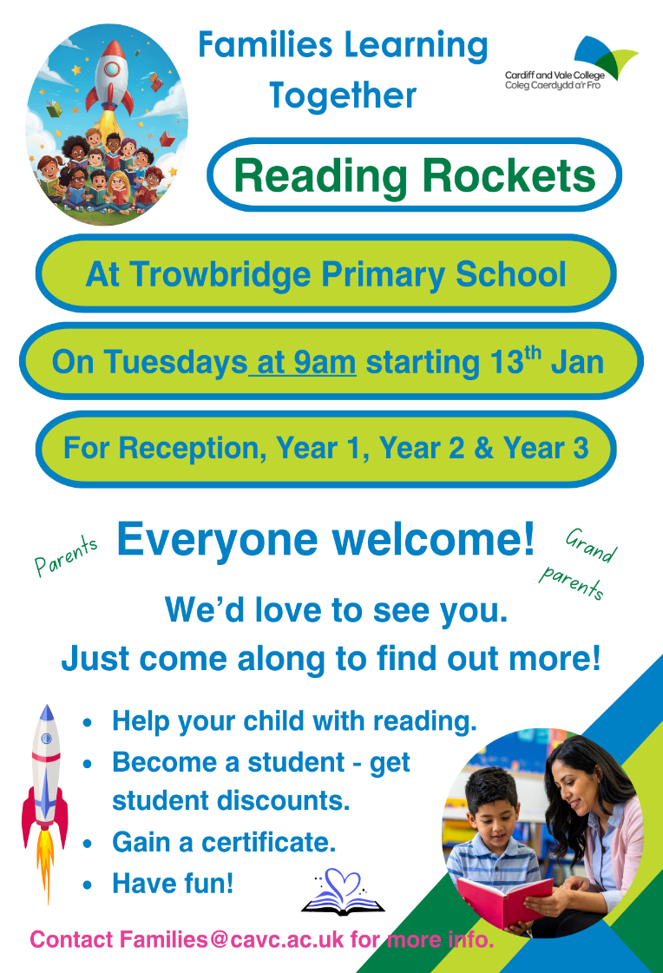
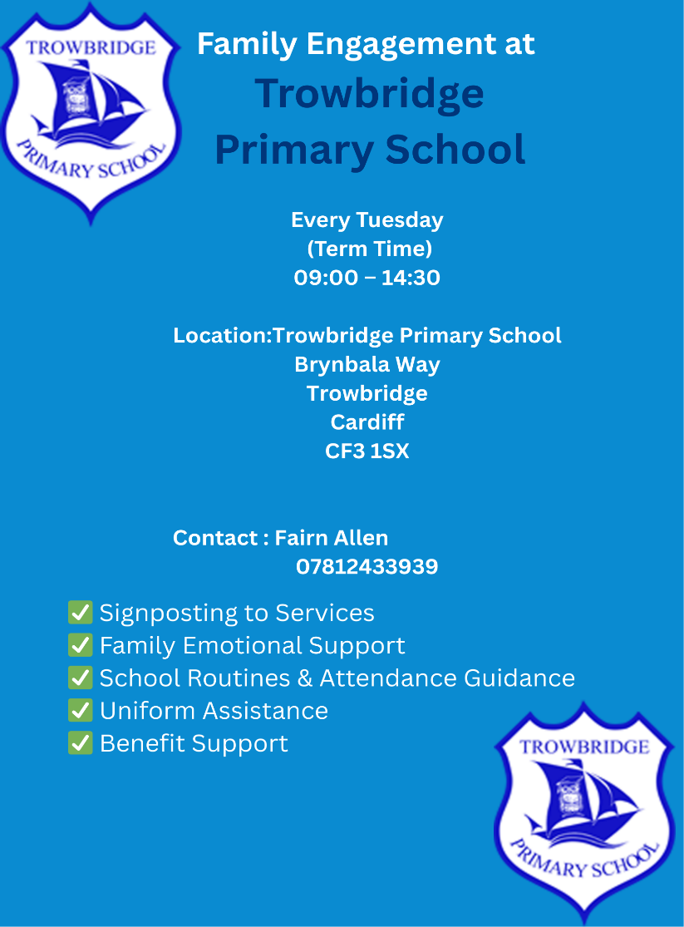

🎄 Thank You for Making Our Christmas Concerts Shine!

A huge thank you to all our families who joined us for this year’s Christmas concerts. Your support, enthusiasm, and festive spirit filled the rooms with joy and made each performance truly special.

✨ Together We Made a Difference

Thanks to your generosity in purchasing raffle tickets, we raised an incredible amount that will go directly back into enriching the experiences of our children. Every pound raised will be spent on resources, activities, and opportunities that help our children learn, grow, and thrive.

