
TROWBRIDGE NEWS
‘Dream. Explore. Discover.’
November 13th 2025




14.11.25 Children in Need Day
14.11.25 Year 4 Trip
20.11.25 Individual / Family Photo Day
2.12.25 Year 6 Crucial Crew
4.12.25 Christmas Enterprise Fair – pm. Details below.
4.12.25 Year 6 Streetwise Road Safety Workshop
5.12.25 Year 2 – Christmas Wrapped Up @ Rumney Chapel
8.12.25 Christmas Swap Shop – Details to follow
10.12.25 Year 2 Kerbcraft
10.12.25 Y4/5/6 Evening Concert – time TBC
11.12.25 Christmas Jumper Day
11.12.25 Christmas Lunch – Order on ParentPay
12.12.25 Year 6 – Eastern High School Christmas performance
12.12.25 Nursery / Reception Concert – time TBC
16.12.25 Year 4/5/6 Morning Concert – time TBC
16.12.25 Year 1/2/3 Afternoon Concert – time TBC
17.12.25 Year 3/4/5/6 Christmas Parties
18.12.25 Nursery, Reception, Year 1 and 2 Christmas Parties
19.12.25 End of Term
5.1.26 INSET Day
6.1.26 Children return to school

10 days absent = 95% attendance
19 days absent = 90% attendance
29 days absent = 85% attendance
38 days absent = 80% attendance
47 days absent = 75% attendance

‘School Motto’

The school Motto is:

‘Believe and you will achieve’

‘Credwch ac fe lwyddwch’

We try to apply this motto throughout our daily work at Newton Primary School.
Mo
School Meals

I would like to take this opportunity to remind you about paying for school meals.

Dinner money should be paid on a Monday in advance of having any school lunch. We would prefer for you to keep up to date with payments rather than having to implement the Bridgend CBC policy.

Thank you for your cooperation with this matter.


Remaining INSET Days 2025-26

Monday 5th January
Monday 23rd March
Monday 8th June
Monday 20th July

Bank Holiday
Monday 4th May

Let Us Know
If you have any concerns about your child, then please contact the school as soon as possible so that we can address the problem. You can telephone 029 20777048 to make a telephone appointment or email us at greenwayprm@cardiff.gov.uk




Christmas Raffle

Christmas raffle tickets will be on sale soon.
Draws will take place at concerts.


Christmas Jumper Day

Wear your favourite Christmas jumper to school on Thursday 11th December.

You can also order Christmas lunch this day on ParentPay.




TROWBRIDGE

Right of the Month – Article 28

I have the right to an education
Maen gen i hawl i gael addysg

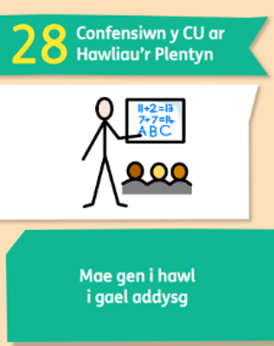




ATTENDANCE RAFFLE

The Oaks Federation have been working hard to try and improve attendance this term. Currently Trowbridge’s overall average attendance is 90%. As a reward for good attendance, we will be holding an attendance raffle for the families whose children achieve 99%+ attendance at the end of term!


Christmas Enterprise Fair
Thursday 4th December, 2:30–3:00pm

Join us for a festive afternoon where each class will sell handmade items!

Families may collect children at 2:30pm to attend the fair from their usual drop-off / pick-up areas.

Children must be accompanied by an adult.
We hope to see you there!





