Year 3 Homework Grid- What a Wonderful Wales
Try to complete one each week to earn yourself some dojo points! Don’t forget to practice your spellings, handwriting and reading at home too 🙂 If you have any questions please feel free to ask!

Maths- Can you track the temperature in Cardiff over a week? Which day was the coldest or hottest?   | Literacy- Write a biography about a famous Welsh person! | Topic- Write a fact file about famous landmarks in Cardiff.  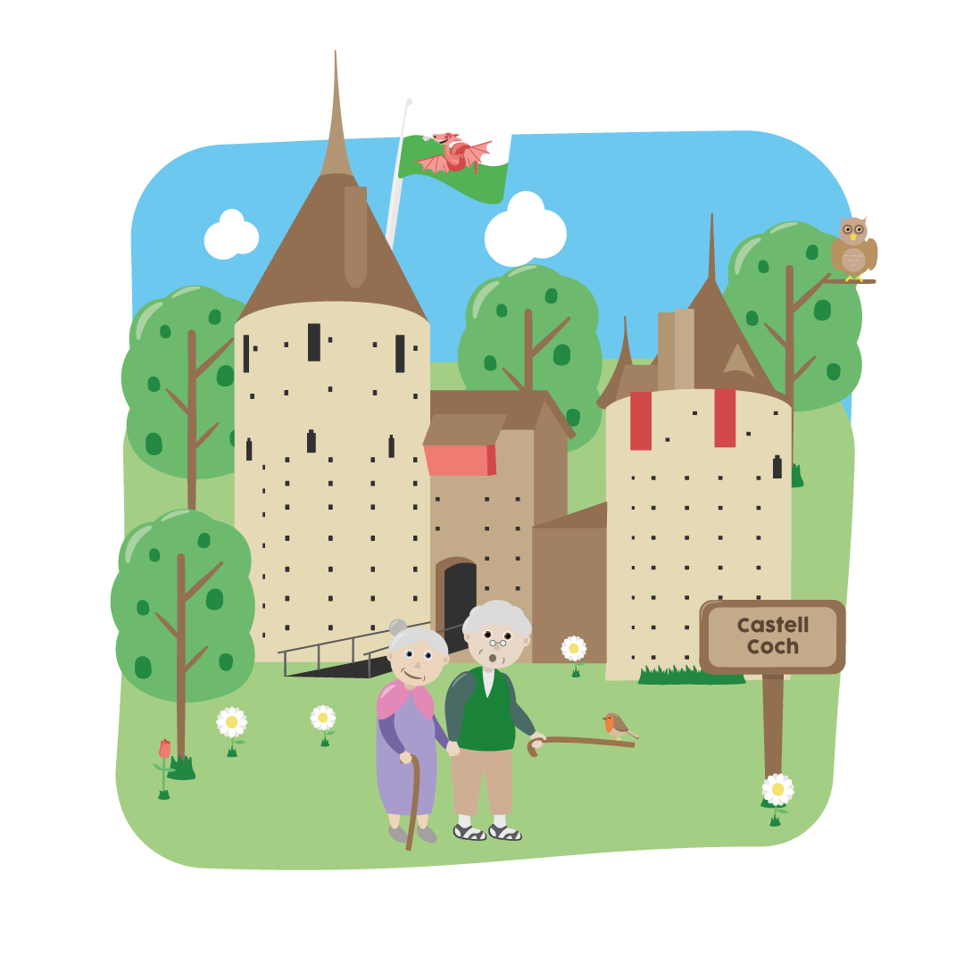 | Art- Can you design a famous Welsh landmark?  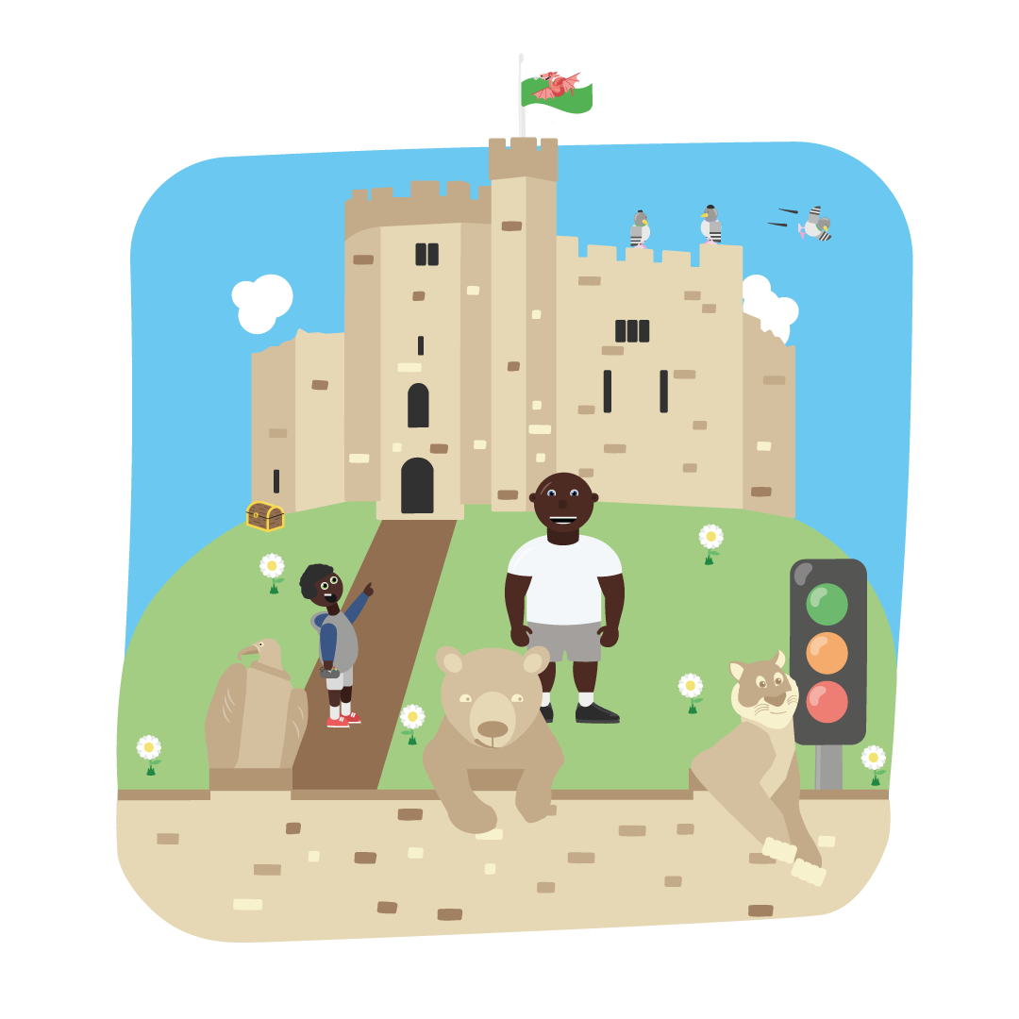 | Welsh- Teach your families the sentence pattern ‘ Dw i’n hoffi…/ Dw i ddim yn hoffi …’  
Maths- Can you create a bar graph of your family’s favourite places to visit in Cardiff?   | Literacy- Create a poster encouraging people to visit Cardiff.   | Science- Can you explore the different habitats and plants you can find in Wales?   | Food Tech- Can you bake your own Welsh cakes?   | Well -being- Scan the QR code to complete a mindfulness activity.  

