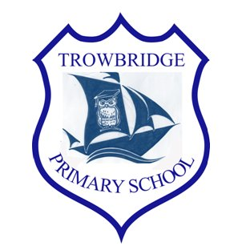
Trowbridge Primary School
Year 3&4 / Blwyddyn 3&4
Welcome back! Here is some useful information for the upcoming term.
Context
Autumn - What a Wonderful Wales
During this topic, learners will explore the beauties of where they live, Cardiff and the rest of Wales.

We will have the opportunity to explore ideas that we have discussed in our Pupil Voice sessions too! Check out website for all of the amazing learning we have been part of at.

https://www.trowbridgeprimaryschool.co.uk/
PE
Y3/4- Thursday – Indoors/ Outdoors

Kit –T-shirt, shorts/leggings or tracksuit bottoms & trainers.

Please remind your child to bring their kit.
During the colder months please make sure children are wearing warmer clothes for when we are working outside.

School starts at 8.55am and finishes at 3pm.
Attendance matters - make sure your child is in school every day!

Home Reading / Spelling
The children will bring home their ‘Home Readers’ on a Friday but are able to change their books when they are finished.Spelling Tests will take place on a Friday.
We use a number of websites that can help your children with spelling, reading and maths. They can be accessed through their Google Classrooms on HWB.

How you can help your child

Listen to them read or encourage them to read books, comics, magazines or newspapers independently.

Support them to do research on a theme, to work out maths questions or to learn spellings for homework.

We look forward to another successful term!
Miss White and Miss Ashcroft.

Fruit Tuck Shop
FRUIT: Every morning, the children can buy a mixed bag of fresh fruit or boxes of dried fruit from the fruit trolley for 30p or £1.50 for the week.

WATER BOTTLES: We want to continue to reduce the number of bottles we throw away so please encourage your child to bring a water bottle to school.

Can children please only bring water to school.

