Nursery & Reception
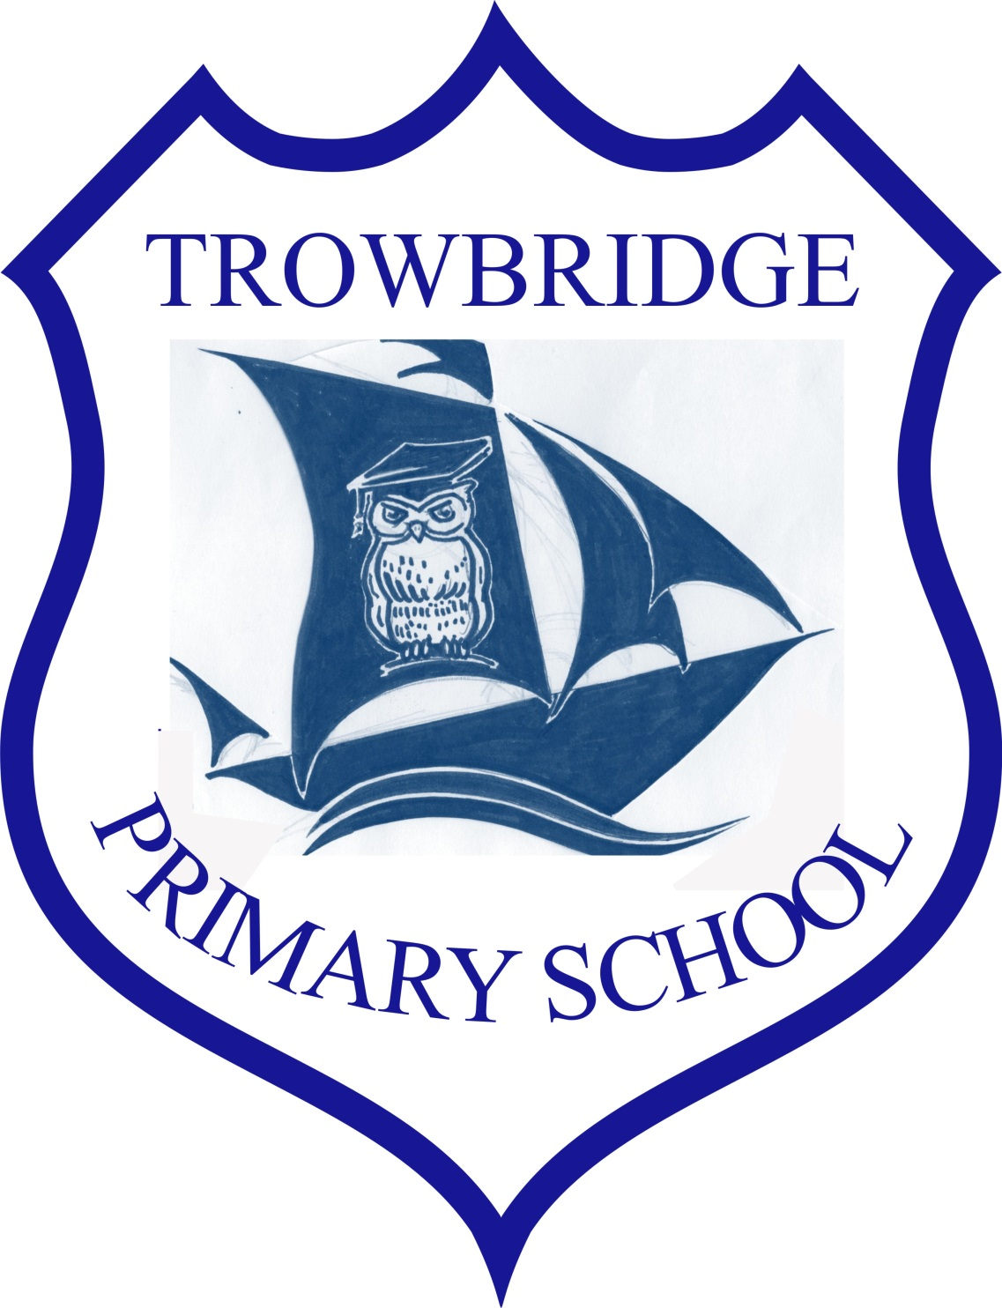Spring
‘Once Upon a Time’

Literacy, Language and Communication and Welsh
We will be learning: To hold our pencil correctly, mark making, writing our name, recognising our name learning our letter sounds and read and spell CVC words.
Reading Texts- Fairy tales (Cinderella, Snow White, Hansel and Gretel) and singing nursery rhymes.
Writing –
Nursery: Mark Making, initial sound of name / writing our name.
Reception: Continue to learn to write our letter sounds and sentences as well as learning to write a sentence using a full stop, finger spaces and capital letters.
Oracy – We will be practicing our oracy in our role play areas as well as in Helpwr Heddiw and in Phonics.
Welsh- We will be learning the weather, singing ‘Sut mae tywydd heddiw?’ and learning our colours, numbers and some animals.

Welcome to Nursery and Reception!

This year we will be continuing to develop the new curriculum in Wales meaning that the children will have more say in what they want to learn. Pupil voice will be leading our teaching and their ideas will be incorporated into our context work on ‘Once upon a time!’

Mathematics and Numeracy
We will be learning:
READING & WRITING NUMBERS: To read and write numbers 3/5/10/20.
COUNTING: Counting to 5/10/20,
Touch counting to 3/5/10.
Counting forwards and backwards to and from 3/5/10
SHAPE: To recognise and explore 2D & 3D shapes.
MEASURING: Measuring different lengths starting at the same point.
POTENTIAL LANGUAGE: To move in given directions. E.g. Move forward, backwards etc
TIME: Nursery will be exploring clocks and reading the numbers on the clock. (Hickory Dickory Dock)
WEIGHT: We will be comparing and estimating weight.

Dates for your Diary
Inset Day: 9th February.
Half Term: 12th- 16th February
St David’s Day: 1st March
PE Days
In Reception our PE day is a Friday.
Please remember trainers, shorts and t-shirt for those days.

Context Work
The children have decided that in each new Area of Learning we will learn:
Humanities (History, Geography and RE):
Expressive Arts (Music, Art, DT and creative movement):
Science and Technology (Science and ICT):
Health and Wellbeing (PE and PSHE):
Our theme this term is ‘Once upon a time’. In nursery and reception, we will be looking at Nursery Rhymes and Fairy tales, such as Humpty Dumpty, Incy Wincy Spider, Cinderella and Snow White etc. We will be investigating what is on a farm, completing a humpty dumpty experiment, finding Cinderella a new shoe by measuring and building a bridge for the 3 Billy Goats Gruff to cross. We will be continuing our Well-Being Wednesday’s and exploring our emotions and our friends’ feelings.
To conclude we will be exploring different celebrations such as Valentine’s Day, St David’s Day and Easter.

We will be having lots of fun and doing lots of outdoor learning!

Homework
Pupils will be given a homework task on the back of the Newsletter. Please complete one a week and your child/children will be given DOJO’S for their participation. This will be collected on a Friday; we look forward to seeing your amazing work.

Nursery: Books to be given out on a Friday and to be returned on a Monday.

Reception: Please practice your sounds of the week and read your reading book.

