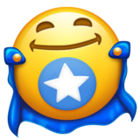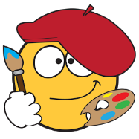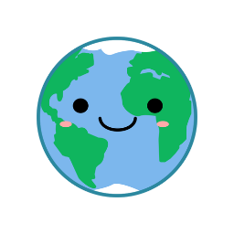

* Pick up rubbish! – Tommy J
* Can we make a house for animals? – Brad
* Animals - Ellis

**Ambitious Ahmed**

* Draw our friends. – Kobie
* Can we do dancing? – Maisie
* Make some music – Tommy B

**Creative Catrin**

* Brush teeth– Christopher
* Do running – Tobias
* Can we do cooking? – Marshall
* Can we eat food? - Cairo

**My World**

* Writing numbers – Jack
* Colouring – Rayan
* My family – Thomas

**Healthy Harry**

Ethical Emma