Blwyddyn 3 Homework Grid
Try and complete one homework task for each week. Don’t forget to practise your spellings and read your books alongside this!

Maths -  Count how many sea animals you can spot in a book, video, or picture and make a simple bar chart or tally chart to show your results. | Literacy -  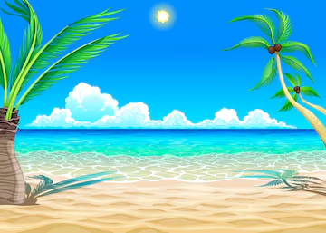  Make a poster that reminds people how to keep the oceans clean. | Topic -  Draw a simple food chain using sea animals and label who eats what.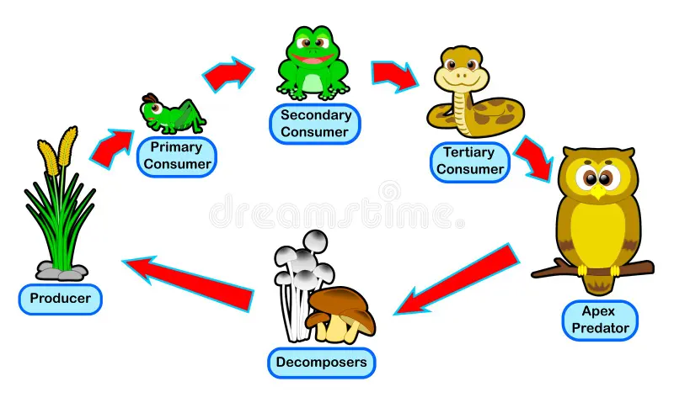 | Welsh -  Draw 4 sea animals and label them in Welsh (e.g. pysgodyn = fish, morfil = whale).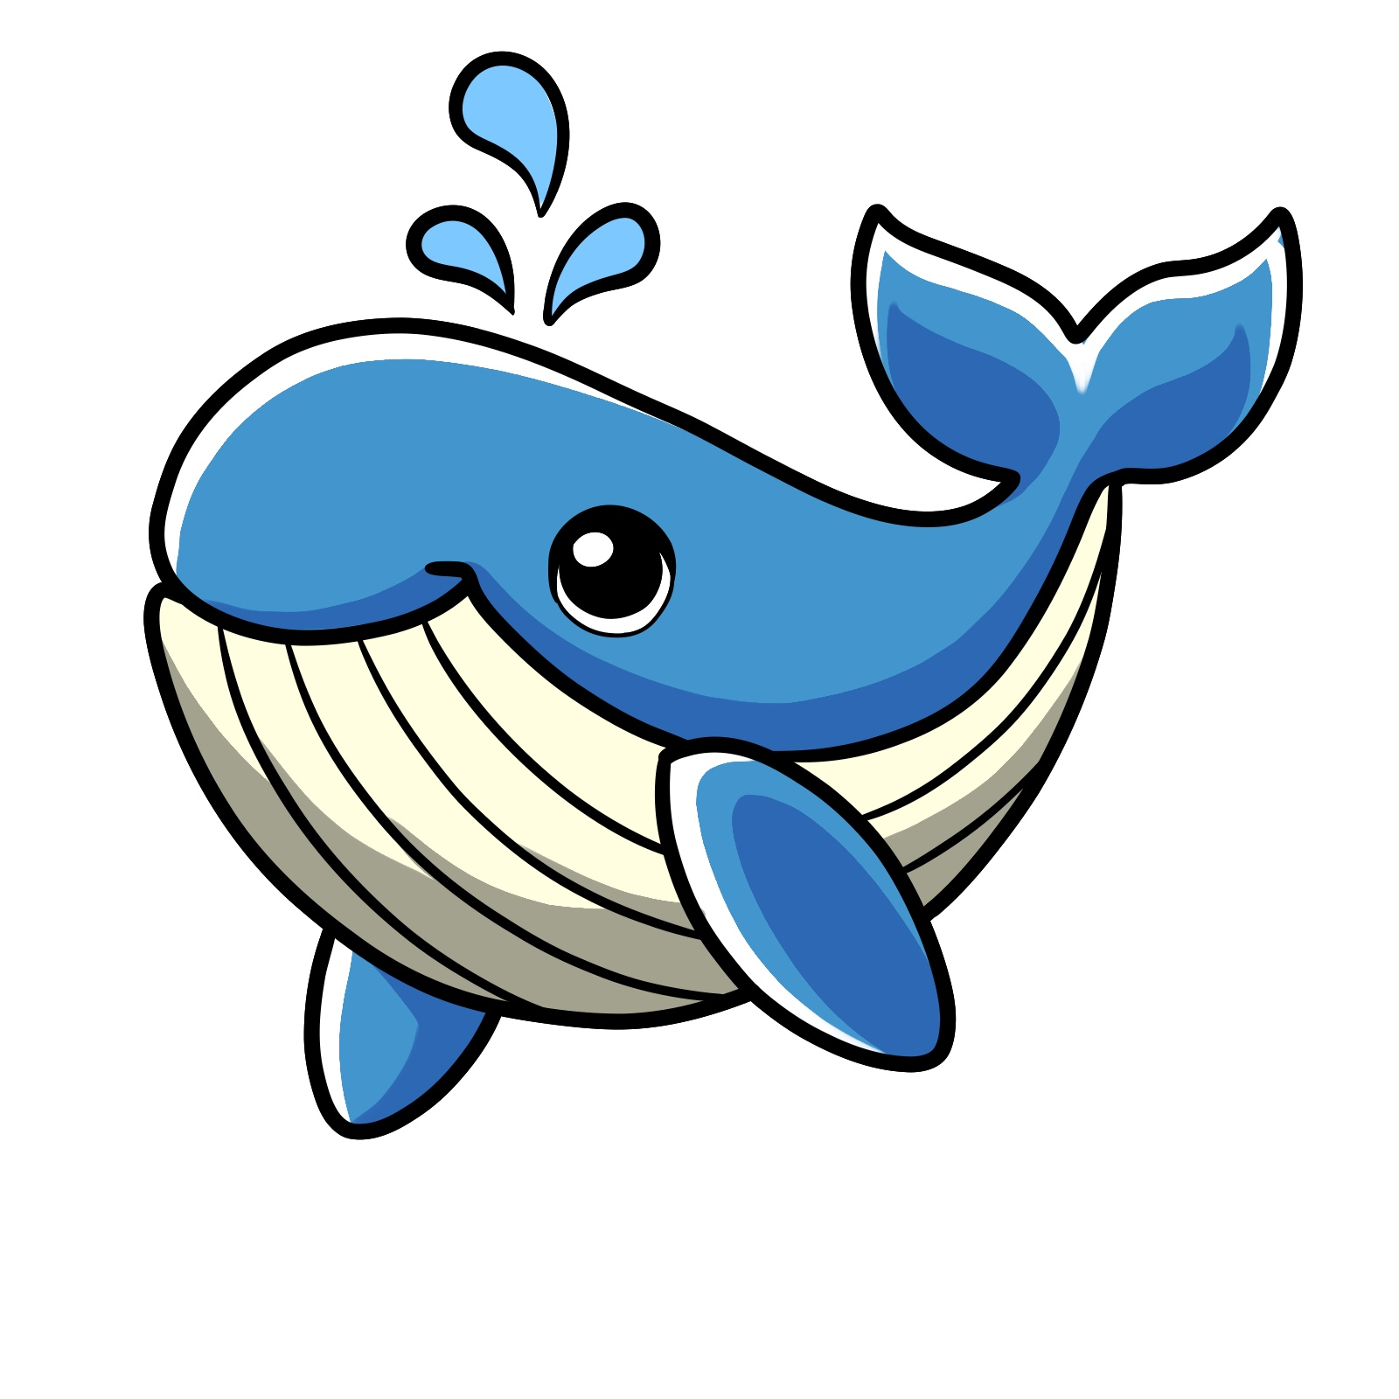
Art -  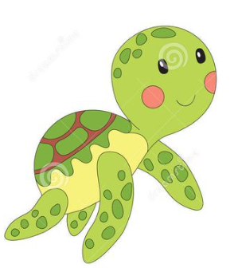  Draw and paint your favourite sea animal and write one sentence about where it lives. | Health & Wellbeing -  Choose 3 sea animals and make up a movement for each one — show how they swim, crawl, or dive, then perform your ocean animal moves for someone at home! | Literacy -  Keep a diary of how you used water in one day and how you could save some.   | Maths -  Write or solve 3 ocean-themed number problems, like “If a dolphin eats 5 fish in the morning and 4 in the afternoon, how many fish does it eat altogether?”

