|  |  |  |
| --- | --- | --- |
| (10 Dojo)  Create a tally chart showing your travel over the week. Keep a track of how often you walk, cycle/scoot, get a bus, go in the car or maybe even go on a train. | (5 Dojo)  Create your own secret message using your own coding system/language. | (20 Dojo)  Design your own island and create your own map and key.  You will need to think about what kind of buildings and natural attractions you would want on your island.  Don’t forget to give your island a name! |
| (15 Dojo)  Research a country of your choice, you could use books or the internet. You could present your research in a fact file, poster, leaflet or on Google Classroom. | (10 Dojo)  Create an art piece on one of the 7 wonders of the world.  You could draw it, make a collage, build it out of lego or create your own model by junk modelling. | (5 Dojo)  Capital city challenge.  See how many Capital cities you and your families know, make a list! |

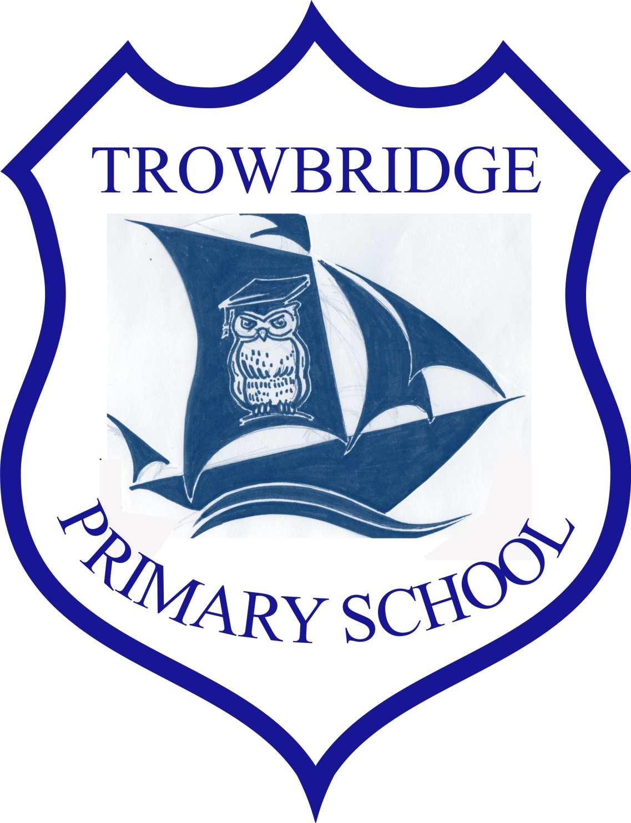

**Health and Well-being**

Health and Wellbeing is a focus for us as a school and as a result we will be have a ‘Wellbeing Wednesday’ session every week where children will learn about the principles of nurture whilst completing a wellbeing/mindfulness task.

**Expressive Arts**

We will be exploring our ‘Globe Trotting’ topic in our Expressive Arts sessions by learning some traditional dances from around the world alongside having a go at learning some songs on instruments used by different cultures.

Over the course of the term Y3 and 4 will have the opportunity to learn some new skills with UPBEAT.

**Science and Technology**

To link with our topic, we will be learning about climate in parts of the world and food chains linked with different animals around the world. There will be plenty of opportunities for Y3 and 4 to use a range of ICT equipment such as iPads, VR goggles and green screen.

**Humanities**

Through the ‘Globe Trotting’ topic we will be studying the continents of the world by labelling maps and using atlases. From our pupil voice sessions we have decided to focus on Spain, France, Egypt, Brazil, India Africa and New Zealand. We will learn about the human and physical features of these countries and also explore their cultures, religions and traditions.

**Key information**

**PE**

PE Day for both Y3 and 4 will be on Thursday.

Children will need to bring in their PE kit and we will get changed before our lesson. PE kit will be kept in the class cloakrooms.

**Trip dates**

We are currently costing different options for a school trip and so we haven’t got a date as yet but we will share this information with you ASAP.

**Homework**

In Y3 and 4 we will send home a reading book and spellings weekly. These will go home with every Friday and will need to be brought back on aweekly. There are also some extra homework tasks on the back of this curriculum map.

**Mathematics and Numeracy**

In our Maths and Numeracy lessons we will be applying our measure, direction, time, money and data handling skills to our Globe Trotting topic. There will also be plenty of problem solving and reasoning throughout.

Every week we will be completing our Big Maths online where we will be working to beat our scores from the previous week.

**Languages, Literacy & Communication**

In our Literacy lessons we will be practicing to improve our reading and comprehension skills through daily GGR sessions. We will be learning about different styles of writing and will focus on learning how to write emails, diary entries, persuasive adverts, story retells and biographies. As part of our daily routine, Y3 and 4 will embed and learn new Welsh sentences and phrases through Helpwr Heddiw sessions and Cross Curricular Welsh.

Our topic for the term is ‘Globe Trotting’ and therefore we will be learning some other languages as we are learning about countries around the world.

**Year 3 & 4**

**Autumn – Globe Trotting**